Template proposal for computing time applications
This template is based on the Gauss Center for Computing (GSC) calls and the PRACE project access calls. The actual kind of information requested for the different calls might very.

0 General project information 1
1 Introduction 1
2 Preliminary Work 1
3 Project Details 1
4 Description of Methods and Algorithms 2
5 Work Schedule 2
6 Code performance 2
7 Estimated computing resources needed on <supercomputer> 3
8 References 5

0 General Project Information
- New project proposal / Project extension for project <project name>
- Period: mm yyyy – mm yyyy
- Project title: <project title>
- Principal investigator/project leader: <name>
  - Job title
  - Organisation name
  - For commercial companies:
    - Is the head office of the organization in Europe?
    - % of R&D activity in Europe as compared to total R&D activity
  - Department
  - Group
  - Address
  - Country
- Project contributors/collaborators

1 Introduction
- Give a short outline of the scientific background of your research, including references. (About 1 page)

2 Preliminary Work
- Provide a brief summary of your preliminary work in connection with the proposed project, including references. (About 1 to 2 pages)

3 Project Details
- Describe your proposed project in detail, structured in sub-projects and/or steps, if applicable.
- Please, include information about:
  - Scientific questions you want to address
  - Scientific goals you want to reach
  - Approach to reach these goals
  - Expected impact on the research area
  - Novelty and timeliness of the proposal
- About 1 to 2 pages per sub-project/step

4 Description of Methods and Algorithms
- Describe the scientific and numerical methods and algorithms you are planning to use/improve/develop.
- Codes, packages and libraries needed to undertake the project, how will these enable the research to be achieved
- About 1 to 2 pages

5 Work Schedule
- Provide a short work schedule for each sub-project/step.
- Include a table and/or Gantt chart.
- About 0.5 pages per sub-project
- Example for a Gantt chart:
Figure 1 Work schedule for the project (Gantt chart)
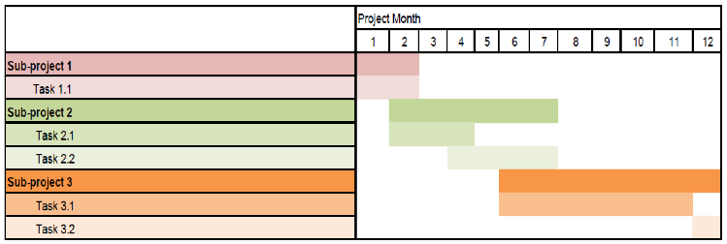

6 Code performance
- Elaborate why <supercomputer> is suitable for your proposed project and why. Include information about:
  - Which code(s) will be used
  - How is the code parallelized (pure MPI, mixed MPI/OpenMP or Pthreads)
  - Amount of memory necessary (per core/node and in total)
  - Scaling plots and table with speedup results for runs with typical parameter sets and problem sizes of the planned project, including I/O
  - Describe architecture, machine/system name, and problem size used for the scaling plots (about 1 to 2 pages)
- Describe your and your team’s experience with the requested kind of architecture.
- An example table and a scaling plot:
Table 1 Scaling behavior of <code> on <architecture> and <system> at <location>. This test was performed with 5*10⁶ particles; absolute timings per time step (s) and relative speedup normalized to 1024 cores are given.
#Cores | Absolute timing (s) | Speedup
1024 | 189.6 | 1.0000
2048 | 99.0 | 1.9154
4096 | 55.6 | 3.4088
8192 | 30.8 | 6.1376
Figure 2 Scaling behavior of <code> on <architecture> and <system> at <location>. This test was performed with 5*10⁶ particles.
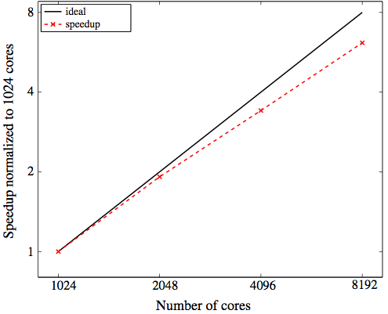
- Hints for BlueGene/Q architectures:
  - In order to use this architecture efficiently, pure MPI codes must use at least 2 tasks per core and hybrid codes must use at least 2 threads per core
  - Scaling data up to at least 8192 cores needs to be presented; within this efficient scaling up to 4096 cores must be demonstrated

7 Estimated computing resources needed on <supercomputer>
- Outline the amount of resources you request for the current granting period and describe in detail:
  - Planned runs
    - Problem size for planned runs
    - Number of runs planned per sub-project and code
    - Number of jobs that can run simultaneously, i.e. jobs that do not depend on each other
  - Are you able to do check pointing?
    - If yes: Maximum time between two checkpoints (in hours)
  - Expected job size (minimum, average and maximum):
    - Estimated computing time per run: wall clock time of a typical job execution in appropriate units, preferred is core hours (core-h)
    - Number of CPU cores/nodes per run, sub-project and code
    - Job memory (total memory usage over all cores of jobs)
  - Total amount of requested computing time
  - Computing time for pre- and/or post processing
  - Storage
    - Total amount of storage required at a time
      - For scratch files during simulation, log files and checkpoints (scratch)
      - Results and large input files (work)
      - Source code and scripts (home)
      - Archive storage (archive)
    - Number of files to be stored (scratch, work, home and archive)
  - Data transfer: total amount of data to be transferred to/from the production system (in GB/TB)
  - I/O
    - Describe the I/O strategy of the code (for example usage of I/O libraries, MPI I/O, netcdf or HDF5)
    - Be aware that I/O has to be adequately managed for highly parallel applications, especially in case of I/O intensive applications.
    - In general, serial I/O is not suitable for large amounts of data.
    - Example:
      - I/O data traffic (read and write) per hour for a typical production job (in GB)
      - Number of files generated per hour for typical production jobs
- Examples for estimating resources:
Table 2 Example 1 for estimating resources (with sub-projects)
Sub-project | Size (particles) | Single $Δt$ 16384 cores | $Δt$ per run | Core-h per run | # Runs | Core-h / sub-project
SP 1 | 8*10⁶ | 40s | 500 | 91,00 | 50 | 4.50 m
SP 2 | 2*10⁶ | 20s | 1000 | 94,00 | 100 | 9.35 m
…
Total requested time on <supercomputer>: n core-h

Table 3 Example 2 for estimating resources (with steps per run)
Run type | # Runs | # Steps/ run | Wall time/ step | # CPU cores | Total core-h/ run type
 | r1 | s1 | w1 | p1 | r1*s1*w1*p1
 | r2 | s2 | w2 | p2 | r2*s2*w2*p2
 | r3 | s3 | w3 | p3 | r3*s3*w3*p3
…
 |  |  |  |  | Total

8 References
<list>

